Lync 2013 checklist v.1.2
Actual for Skype for Business Server 2015
Minimal hosted configuration
Basic services:
1 x Lync Front-End server
1 x Lync Edge server
1 x IIS ARR server (reverse proxy for Front-End services)

Recommended by Hosting.Build
High available basic services:
2 x Lync Front-End server
2 x Lync Edge server
2 x IIS ARR server (reverse proxy for Front-End services)
Good features:
1 x Persistent Chat server
if you want to users to be able to participate in multiparty, topic-based conversations that persist over time. To provide more capacity and increased reliability, your topology can include multiple computers running Persistent Chat Server. You cannot collocate Persistent Chat Server with other server roles in an Enterprise pool. However, you can collocate Persistent Chat Server on a Standard Edition server. Persistent chat requires a database and, if you implement persistent chat compliance, a persistent chat compliance database, but the databases can be collocated with the Archiving database, Monitoring database, or on the Back End Server of an Enterprise Edition Front End pool. For details about planning the appropriate Persistent Chat Server topology, see Planning for Persistent Chat Server in Lync Server 2013 in the Planning documentation.
1 x Office Web Apps server
which is used with Office Web Applications in Lync Server 2013 to handle the sharing and rendering of Microsoft PowerPoint presentations.
DNS records
In below example hosting.net is the internal domain and hosting.com is the external.
Important: We assume you will not try to connect internal clients and all connections will be external (through Edge and IIS ARR).
Internal DNS A records
FQDN Example | Maps to | Your FQDN (fill this column)
LyncPool01.hosting.net | Pool01 (DNS load balancing). Requires a DNS A record for the IP address of each Front End Server within the pool, mapping to the pool FQDN.
Lyncfe01.hosting.net  Lyncfe02.hosting.net  Lyncfe03.hosting.net  … | Pool01 Front End Server (NODE 1).  Pool01 Front End Server (NODE 2).  Pool01 Front End Server (NODE 3).  …
EdgePool01.hosting.net | Edge Pool01 (DNS load balancing). Requires a DNS A record for the IP address of each Edge Server within the pool, mapping to the pool FQDN.
Lyncedge01.hosting.net  Lyncedge02.hosting.net  Lyncedge03.hosting.net  … | Pool01 Edge Server (NODE 1).  Pool01 Edge Server (NODE 2).  Pool01 Edge Server (NODE 3).  …
External DNS A Records
FQDN Example | Maps to | Your FQDN (fill this column)
sip.hosting.com | Edge Server
webcon.hosting.com | Edge Server
av.hosting.com | Edge Server
meet.hosting.com | Reverse Proxy server
dialin.hosting.com | Reverse Proxy server
lync.hosting.com | Reverse Proxy server
lyncdiscover.hosting.com | Reverse Proxy server
DNS CNAME records (for each customer’s domain)
FQDN Example | Maps to
Lyncdiscover.<sipdomain> | lync.hosting.com
DNS SRV records (for your and each customer’s domain)
FQDN Example | Maps to
_sipfederationtls._tcp.<sipdomain> | sip.hosting.com  port 5061
_sip._tls.<sipdomain> | sip.hosting.com  port 443
Ports used by Lync 2013

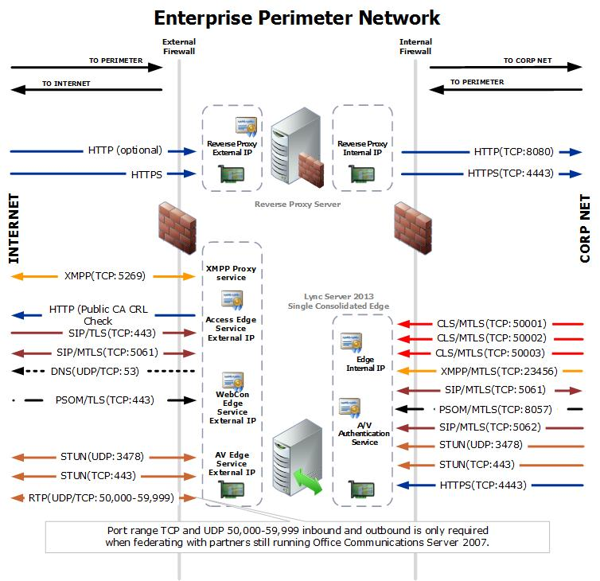

Detailed description: http://technet.microsoft.com/en-us/library/gg398798.aspx

!!! Set-CsProxyConfiguration –Identity global –TreatAllClientsAsRemote $false

